

Professional massage treatment

- A helping hand when you need it! -

Tel: 0751 3923323

Emergency Services Price List

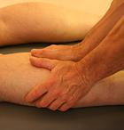
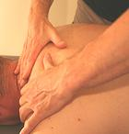
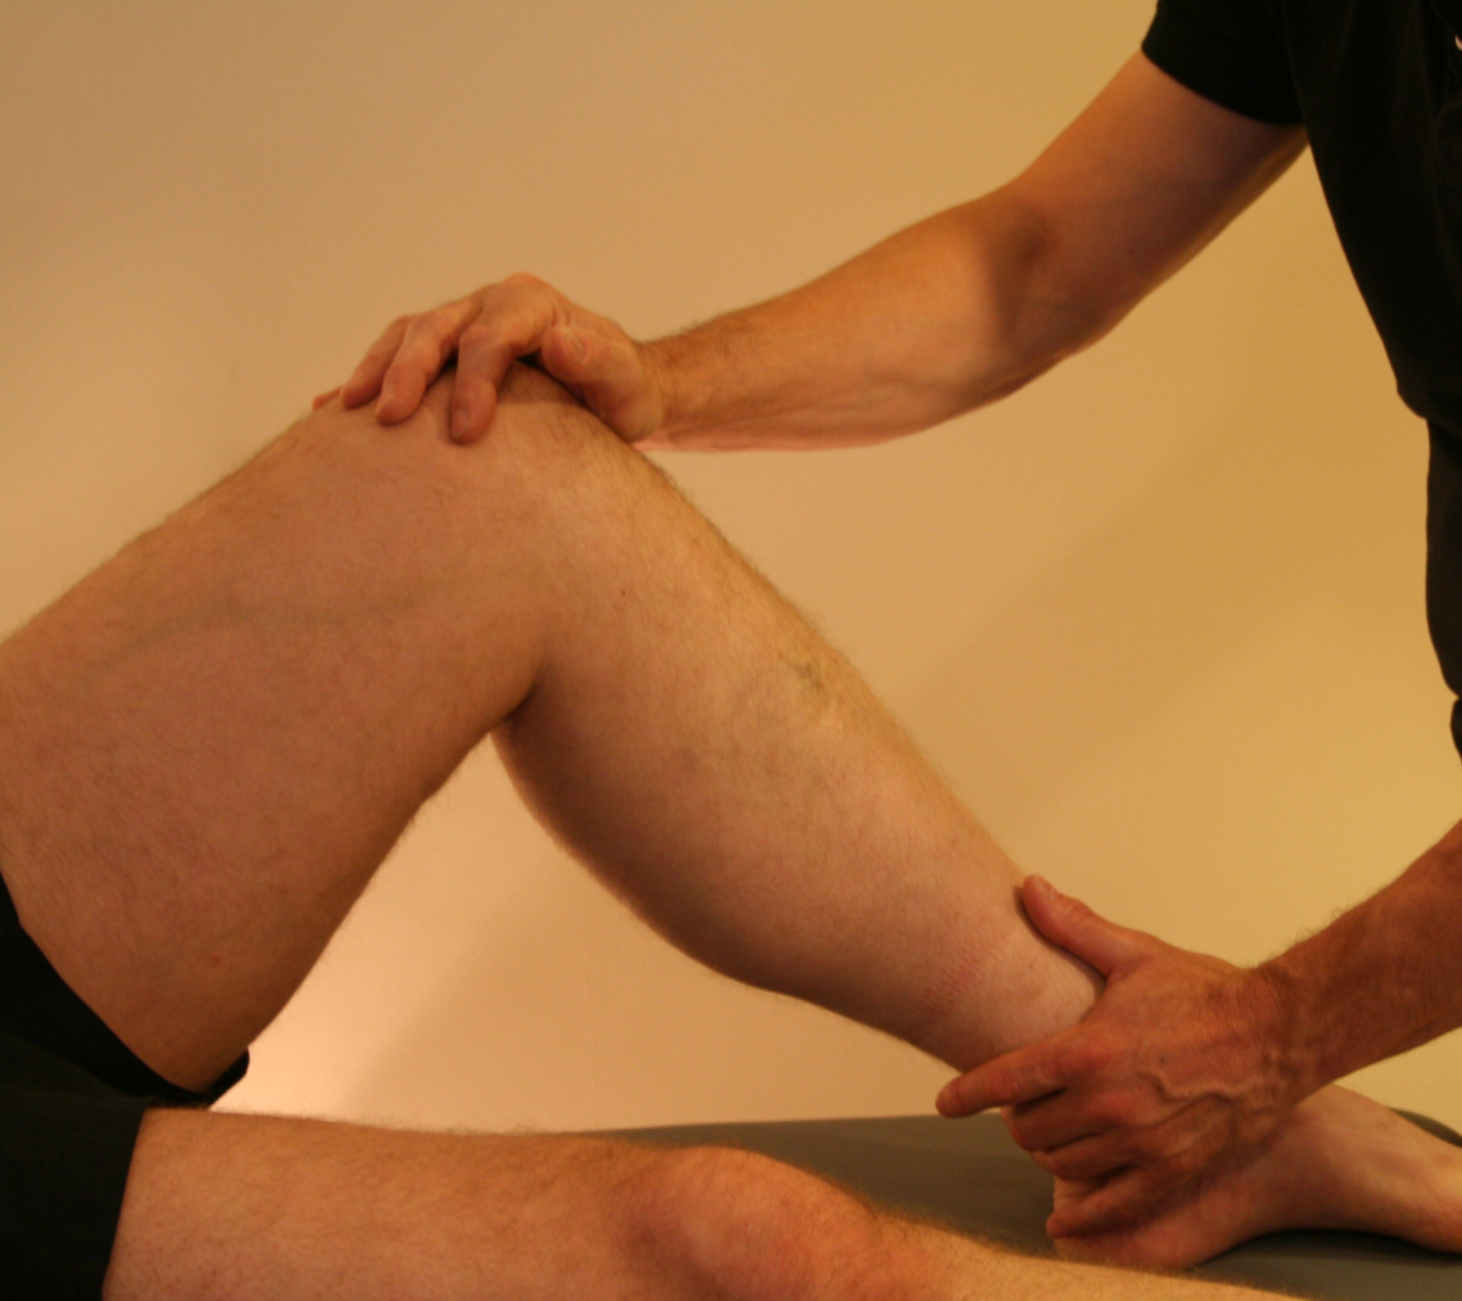

Sports Massage:
Involves a combination of firm direct pressure to the major muscle groups, trigger point therapy and facilitated stretching which are used to increase muscle function. Sports massage is designed to improve athletic performance, reduce recovery time and reduce the risk of injury during physical activity.

 | Usual price | Special price
30 minute treatment | £25.00 | £20.00
45 minute treatment | £33.00 | £28.00
60 minute treatment | £40.00 | £35.00

Available at: Jarrow Chiropractic
5 Wylam street
Jarrow
NE32 3HU

Please Note: A 45 minute session is recommended for first visit to collect medical information and conduct required assessments.

